Aircraft Design 1 – Fall 2025

Assignment 2: Preliminary & Propulsion Sizing

Student Names and USCIDs:

Aurelio Santiago, C30461119

Mateo Garcia, V02125756

Jacob Chin, C96554174

Instance 1

Hours spent on assignment: 10h

Aircraft type: Business Jet

Aircraft number: 110

Table 1: Requirements Table

|  |  |  |
| --- | --- | --- |
| Requirement Type | Value | Unit |
| Payload | 1100 | Kg |
| Range | 3600 | km |
| Cruise Altitude |  | m |
| Cruise Speed | 830 | km/hr |
| Take-off Distance | 1200 | m |
| Landing Distance | 860 | m |
| Propulsion System | jet |  |

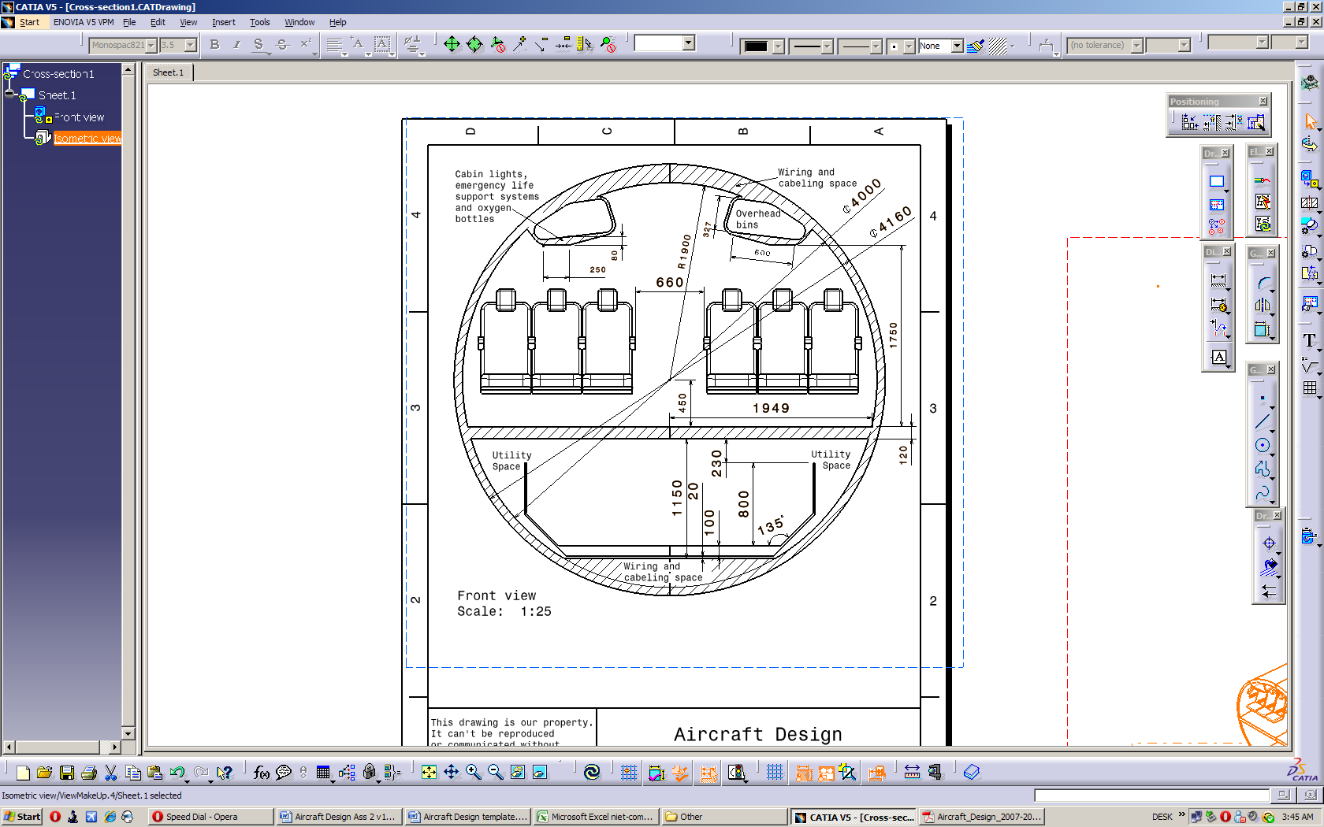

Table of Contents

1 – Introduction 4

2 -- Preliminary Sizing & Performance 5

2.1 – Fuel Fraction & Weight Estimation 5

2.2 – Sizing Graphs 5

3 -- Preliminary Engine Sizing 5

References: 6

Appendix 1: Additional Information 7

# 1 ­– Introduction

# 2 -- Preliminary Sizing & Performance

This section discusses the various components estimating fuel/payload weight and the bounds for propulsion and weight requirements/limits.

## 2.1 – Rapid Sizing For Aircraft Weight

This will include rough estimates for the weight of fuel in both types of flight sections and other weight factors to get a general estimate of the weight of the aircraft.

**2.1.1 – Non-Fuel Intensive Flight Section**

Using data from a table in Reference 1 of typical fuel consumption of business jets along with the equation for mass fuel fraction, the equation becomes:

$${M'}_{ff}=\frac{W_{1}}{W_{TO}}\prod_{i=1}^{i=n}{\frac{W_{i+1}}{W_{i}}=0.990*0.995*0.995*0.980*0.990*0.992=}0.94331$$

With the final answer being the fraction of weight left over after fuel has been used for these non-intensive phases (engine start & warmup, taxi on, take-off, climb, descent, landing, taxi off, and shutdown). This number can be used in subsequent sections to determine total fuel consumption.

**2.1.2 – Fuel Intensive Flight Section**

Equations for fuel consumption in this flight section become more particular to the aircraft due to determinations of range and flight speed. From the initial requirements, the range is 3600 km and the cruise speed is 830 km/hr (230.556 m/s). From the table of typical cruise data [Ref 1], there are ranges of L/D and cj values which can be used to calculate the weight fraction after cruising. Using average cruising values L/D = 11 and cj = 0.7 lbm/hr/lbf (19.829 mg/Ns), the equation becomes:

$${\left(\frac{W_{i}}{W_{i+1}}\right)}_{cruise}=e^{\frac{R}{{\left(\frac{V}{g*c_{j}}\right)}_{cruise}*{\left(\frac{L}{D}\right)}_{cruise}}}=e^{\frac{3600000}{\left(\frac{230.556}{9.80665*19.829*{10}^{-6}}\right)*11}}=1.317886$$

$${\left(\frac{W_{i+1}}{W_{i}}\right)}_{cruise}=0.758791$$

This number is the weight fraction left over specifically after the cruise phase. Next, the loitering phase will be calculated based on legal requirements for loiter endurance. There will be added sections for a second (lower) climb, loitering, and another descent covering an endurance of at least 45 minutes (2700 s). The loiter section will be assumed to be 20 minutes (1200 s). Using loiter values of L/D = 13 and cj = 0.5 lbm/hr/lbf (14.164 mg/Ns) the equation for this section is:

$${\left(\frac{W_{i+1}}{W_{i}}\right)}_{loiter}=e^{\frac{-E}{{\left(\frac{1}{g*c_{j}}\right)}_{loiter}*{\left(\frac{L}{D}\right)}_{loiter}}}=e^{\frac{-1200}{\frac{1}{9.80665*14.164*{10}^{-6}}*13}}=0.98726$$

Factoring in another climb section, cruise section (covering 20 minutes), the prior loiter calculation, and a final descent, the full reserve fuel section would be:

$${\left(\frac{W_{i+1}}{W_{i}}\right)}_{reserve}=0.990*e^{\frac{-1200}{{\left(\frac{1}{g*c_{j}}\right)}_{cruise}*{\left(\frac{L}{D}\right)}_{cruise}}}*0.98726*0.990=0.947304$$

Overall, the fuel for the whole flight will be represented as a fraction of the take-off weight as follows:

$$W_{fuel}=W_{Fused}+W_{Fres}$$

$$W_{fuel}=W_{TO}*\left(1-\left(0.758791*0.94331\right)\right)+W_{TO}*\left(1-0.947304\right)=0.336921*W_{TO}$$

**2.1.3 – Take-off Weight Estimation Graphs**

For this section, the reference aircraft will be graphed based on empty weight vs take-off weight to determine a trendline. This trendline equation will be used to form the full equation to find the take-off weight directly. Compiling relevant reference aircraft and graphing empty weight vs take-off weight results in this graph:

**2.1.4 – Total Weight Estimation**

In prior sections, the various aspects of the aircraft weight were calculated as a fraction of the take-off weight. The original equation for the take-off weight is the following:

$$W_{TO}=W_{E}+W_{F}+W_{PL}+W_{crew}+W_{tfo}$$

Where WTO is take-off weight, WE is empty weight, WF is fuel weight, WPL is payload weight, Wcrew is weight of the crew, and Wtfo is the weight of the trapped fuel and oil.

The weight of the fuel was calculated in a previous section, payload and crew weight were given and calculated in the requirements, trapped fuel and oil can be estimated at around 0.3% of the take-off weight, and the prior section calculated empty weight as a function of take-off weight.

## 2.2 – Sizing Graphs

# 3 -- Preliminary Engine Sizing

3.1 Stall Sizing

The lift equation can be rearranged and used to find the wing loading.

$$\frac{W}{S}=\frac{1}{2}*ρ*{V_{s}}^{2}*C_{Lmax}$$

From statistical information one can estimate the values of $C_{Lmax}$ for its clean, take off, and landing configurations. While direct stall speed data for aircrafts are limited, reasonable estimates were derived using values reported for similar aircraft.

|  |  |  |
| --- | --- | --- |
| Configuration | $C_{Lmax}$ [-] | $V_{s}$ [m/s] |
| Clean | 1.8 | 51 |
| Take off | 2.2 | 43 |

These values were selected based on commonly accepted estimates for stall speeds and average lift coefficients. However, they are not the primary drivers of the design, since the more restrictive landing requirements will ultimately govern the wing sizing. By using Eq. 3.1 and the values in table 3.1 the maximum possible wing loading for the two configurations are

Clean $\frac{W}{S}=$ 2855 ${N/m}^{2}$

Take off $\frac{W}{S}=$ 2481 ${N/m}^{2}$

3.2 Take off Sizing

There are many influencing factors driving take off requirements. All these factors combined create the take-off parameter (TOP).

$${TOP}_{jet}={\frac{W}{S}}_{TO}*{\frac{W}{T}}_{TO}*\frac{1}{C_{Lmax}}*\frac{1}{σ}$$

The Take-off Parameter (TOP) is derived from statistical data. By examining several reference aircraft, each of their TOP values can be determined and plotted against their corresponding take-off distances. Sigma in Eq 3.2 is the ratio of air density at sea level and will be noted as being equal to 1 due to $ρ$ and ${ρ }_{0}$ being equal.

3.3 Landing Sizing

# References:

# Appendix 1: Additional Information